Dataset 2: Stroop Incongruence & Processing Time

Scenario Overview
Students completed a classic Stroop task in which they named the ink colour of printed words. Each student responded to congruent trials (word and ink match) and incongruent trials (word and ink conflict). Mean response time (ms) is shown with SD error bars.

Data Summary
Condition | Mean response time (ms) | Error / SD
Congruent | 520 | 40
Incongruent | 640 | 55

Figure
Figure 1. Mean response time (±SD) for congruent and incongruent Stroop trials.
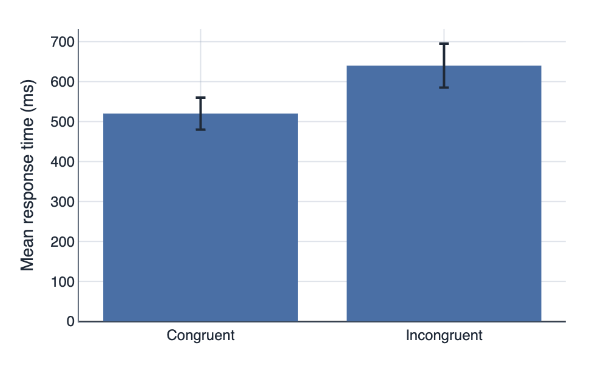

IA1 Practice Questions
- Calculate the size of the Stroop effect in milliseconds.

- Calculate the percentage increase in response time from congruent to incongruent trials.

- Contrast the congruent and incongruent conditions in terms of processing time.

- Sequence the conditions from fastest to slowest response time.

- Infer what stimulus incongruence implies about attentional control in this task.

- Draw a conclusion about the effect of incongruence on processing time, referencing the statistical significance of the results.

